Event or incident: describe some incident or set of circumstances.
Response: describe your feelings and thoughts concerning the incident at the time when it was happening. This is the initial, without the benefit of reflection
Reflection: reflect on the incident. This reflection usually occurs sometime after the event or incident. In the reflection, the transition from describing a situation unique to you to a discussion more universal in nature.

Your Assignment
Your assignment is to write and present a multi-paragraph reflective essay about a significant personal experience that involves the pursuit of happiness and/or transcendental ideals, being sure to describe the experience and your immediate response to it, as well as to reflect on the significance of the experience. The experience should have changed your perspective or led to a lesson that produced some type of realization/epiphany.
Be sure to:
- describe the experience
- Your immediate response to it
- Reflect on the significance of the experience
Assignment must be
- five paragraphs
- 12 font Times New Roman
- MLA Heading (Your first/last name, course, my name, date)
- Have a title – must be creative
- Use purposeful diction, details, and varied syntax
- Include dialogue
- Include imagery
- Flow in a logical fashion (the experience should be easily identifiable)
- Provide a sense of satisfaction at the end (the story was completely told)
- Contain few (to none) errors in standard writing conventions
- Address the theme of pursuit of happiness or transcendentalism

- Challenge yourself to use some of your vocabulary terms from this semester!

Brainstorm two possible topics/events to write about. These are quick notes. Bullet points. Each event should address the following:
- Describe the experience. Why was it significant? How does it represent the pursuit of happiness/transcendentalist ideal? What realization/lesson did you learn?
Describe an experience #1  How does it relate to Pursuit of Happiness/Transcendentalism? | Your response/reaction:  What was significant about the experience/event? What did you learn or take away from this?
Describe an experience #2  How does it relate to Pursuit of Happiness/Transcendentalism? | Your response/reaction:  What was significant about the experience/event? What did you learn/take away from this?
Now, choose the event that you will write about:
Detailed planning for your personal essay
Now, think back on the event and your response. What are feelings after the fact? (Reflect on the incident. This reflection usually occurs sometime after the event or incident. In the reflection, the transition from describing a situation unique to you to a discussion more universal in nature.)

How did you respond to the incident in the previous box? (Describe your feelings and thoughts concerning the incident at the time when it was happening. This is the initial response, without the benefit of reflection)

What Event or incident are you writing about?(Describe your event/experience/incident/ or set of circumstances.)

How does this connect to the pursuit of happiness/Transcendentalism?

Final Paper Checklist:
I have the following items in my paper:
- 5 paragraphs that include:
- An introduction paragraph that includes a hook ( a purposeful quote, anecdote, startling fact/statement/opinion, etc.)
- Body paragraph #1: Detailed Event
- Body paragraph #2: My Actions/Response
- Body paragraph #3: Reflection on the event
- A conclusion paragraph that summarizes my main points. Provides a finish feeling to my essay. The story was completely told.
- My paper connects to the theme pursuit of happiness/Transcendentalist
- I have written in MLA format (12 font, Times New Roman, Double Spaced)
- MLA Heading (Your first/last name, course, teacher’s name, date [Day Month Year –no punctuation])
- MLA Header (Last name Page #)

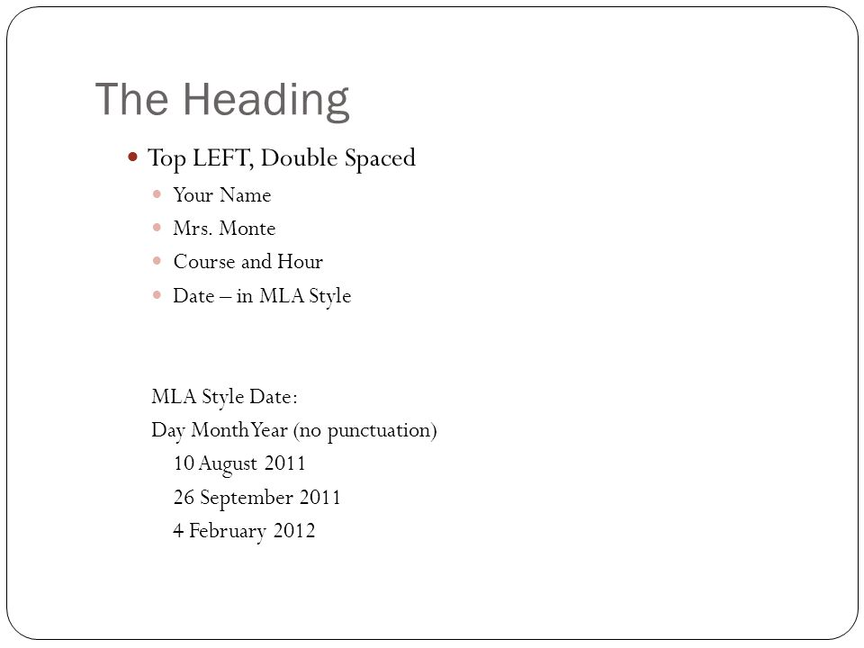

- Have a title – an original title
- Use purposeful diction, detail and syntax
- Include dialogue
- Include imagery
- Includes transition words/phrases (refer to list of transitions)
- Flow in a logical fashion (the experience should be easily identifiable
- Contain few (to none) errors in standard writing conventions that interfere with the meaning/understanding of my paper

Some ideas from class brainstorms:
- Journey to understanding life is short
- Journey to realizing I am the responsible child
- Journey to realizing cultural diversity/awareness
- Journey to becoming self-less
- Journey to finding love
- Journey to loving oneself
- Journey to understanding my academic deficits
- Journey to my independence
- Journey to becoming mature
- Journey to realizing my intelligence
- Journey to understanding my giftedness
- Journey to becoming academically responsible
- Journey to accepting myself
- Journey to accepting others
- Journey to dealing with a change in family dynamics
- Journey to moving past regrets
- Journey to understanding/dealing with/overcoming loss
- Journey to living with my new normal
- Journey to living with my reality
- Journey to strengthening my faith
- Journey to accomplishing greatness
- Journey to peace and love
- Journey to becoming me

